What is the use of Ansible?
Ansible is an automation tool. It lets you perform the same tasks on one or many servers automatically, instead of logging into each server and typing commands manually.
Without Ansible
Suppose you have 100 Ubuntu servers and you want to install Nginx.
You would have to:
- SSH into Server 1.
- Run:
- sudo apt update
sudo apt install nginx -y
- SSH into Server 2.
- Repeat the same commands.
- Continue until all 100 servers are configured.
This is slow and prone to mistakes.

With Ansible
You write a playbook once:
---
- name: Install Nginx
hosts: all
become: yes

tasks:
- name: Install nginx
apt:
name: nginx
state: present
update_cache: yes
Then run:
ansible-playbook -i inventory.ini install_nginx.yml
Ansible connects to all servers in your inventory and installs Nginx automatically.
Ansible works by connecting to remote servers, executing tasks, and then disconnecting. It does not require an agent to be installed on the target machines. Instead, it uses SSH (for Linux) or WinRM (for Windows) to communicate with the managed nodes.
How Ansible Works (Step by Step)
Control Node
(Where Ansible is Installed)
|
| SSH
|
----------------------------------------
| | |
Managed Node 1 Managed Node 2 Managed Node 3
(Ubuntu) (CentOS) (Amazon Linux)
Step 1: Install Ansible
Install Ansible on one machine called the Control Node.
Example:
sudo apt update
sudo apt install ansible -y

Step 2: Create an Inventory
An inventory contains the list of servers Ansible will manage.
Example (inventory.ini):
[webservers]
192.168.1.10
192.168.1.11

[dbservers]
192.168.1.20

Step 3: SSH Connection
When you run an Ansible command:
ansible webservers -m ping
Ansible:
- Reads the inventory.
- Finds the webservers.
- Uses SSH to connect.
- Executes the task.
- Returns the output.
Example:
Control Node
|
| SSH
|
+------------------+
| Managed Server |
| Executes "ping" |
+------------------+
|
Returns Success
Output:
192.168.1.10 | SUCCESS => {
"changed": false,
"ping": "pong"
}

Step 4: Execute Modules
Ansible performs work using modules.
Examples:
Module | Purpose
ping | Check connectivity
apt | Install packages on Ubuntu
yum | Install packages on RHEL/CentOS
service | Start/stop services
copy | Copy files
file | Create/delete files or directories
user | Create or manage users
Example:
ansible webservers -m apt -a "name=nginx state=present" -b
This command:
- Connects via SSH.
- Installs Nginx.
- Returns the result.

Step 5: Playbooks
Instead of typing commands repeatedly, write them in a YAML file called a playbook.
Example:
---
- hosts: webservers
become: yes

tasks:
- name: Install Nginx
apt:
name: nginx
state: present

- name: Start Nginx
service:
name: nginx
state: started
Run it:
ansible-playbook install_nginx.yml
Ansible executes each task in order.

Complete Workflow
User
|
| ansible-playbook install_nginx.yml
|
V
Control Node
|
Reads Inventory
|
Reads Playbook
|
Connects via SSH
|
-----------------------
| | |
Server 1 Server 2 Server 3
| | |
Install Install Install
Nginx Nginx Nginx
| | |
Returns Returns Returns
Success Success Success

Why No Agent Is Needed?
Unlike tools such as Puppet or Chef, Ansible does not require software to be installed on every managed server.
It only needs:
- SSH access
- Python installed on the Linux target machine (most Linux distributions include it)
This makes Ansible lightweight and easy to adopt.

Example: Installing Nginx on Three Servers
Suppose you have:
Server1
Server2
Server3
You run:
ansible-playbook install_nginx.yml
What Ansible does:
- Reads the inventory.
- Connects to Server1 → installs Nginx.
- Connects to Server2 → installs Nginx.
- Connects to Server3 → installs Nginx.
- Displays a summary.
Example output:
PLAY RECAP

server1 : ok=2 changed=1 failed=0
server2 : ok=2 changed=1 failed=0
server3 : ok=2 changed=1 failed=0

Key Components of Ansible
Component | Purpose
Control Node | Machine where Ansible is installed
Managed Nodes | Servers being managed
Inventory | List of servers
Modules | Units of work (install packages, manage users, etc.)
Playbooks | YAML files describing automation tasks
SSH | Secure connection to Linux servers
YAML | Human-readable language used to write playbooks

One-line Summary
Ansible works by reading an inventory of servers, connecting to them over SSH, executing modules defined in commands or playbooks, collecting the results, and disconnecting—without requiring any agent on the managed machines.
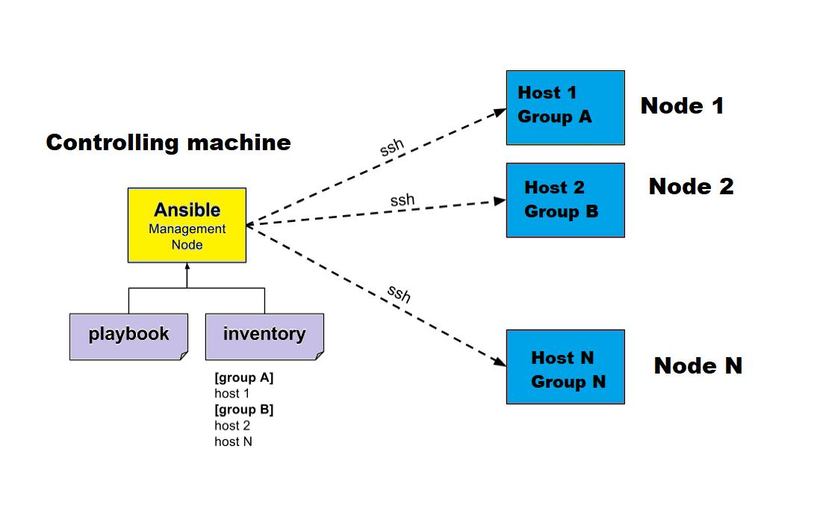
What is Dynamic Inventory in Ansible?
A Dynamic Inventory is an inventory that is generated automatically by querying a cloud provider, virtualization platform, or another external source instead of manually maintaining a list of servers.
Instead of writing server IPs in a file, Ansible discovers the servers automatically.

Static Inventory vs Dynamic Inventory
Static Inventory | Dynamic Inventory
Servers are added manually. | Servers are discovered automatically.
Best for small environments. | Best for cloud environments (AWS, Azure, GCP).
Needs manual updates when servers change. | Updates automatically whenever servers are added or removed.
Static Inventory Example
[webservers]
192.168.1.10
192.168.1.11

[dbservers]
192.168.1.20
If a new EC2 instance is created, you must manually add its IP.

Dynamic Inventory Workflow
User
│
▼
ansible-playbook site.yml
│
▼
Dynamic Inventory Plugin
│
▼
Queries Cloud Provider
(AWS / Azure / GCP)
│
▼
Gets Current Server List
│
▼
Connects to Servers using SSH
│
▼
Executes Tasks

Example with AWS EC2
Suppose you have:
EC2-1
EC2-2
EC2-3
Tomorrow you launch:
EC2-4
EC2-5
With a static inventory, you must manually edit the inventory file.
With a dynamic inventory, Ansible automatically discovers EC2-4 and EC2-5 by querying AWS.

Architecture
Control Node
(Ansible Installed)
│
│
AWS Inventory Plugin/API
│
┌──────────────┴──────────────┐
▼ ▼
AWS EC2 API Inventory Generated
│
▼
+---------+ +---------+ +---------+
| EC2-1 | | EC2-2 | | EC2-3 |
+---------+ +---------+ +---------+

How It Works
- You run an Ansible playbook.
- Ansible calls the dynamic inventory plugin.
- The plugin queries the cloud provider (for example, AWS EC2).
- The cloud provider returns the current list of servers.
- Ansible connects to those servers over SSH.
- Tasks are executed.

Example AWS Dynamic Inventory Configuration
plugin: amazon.aws.aws_ec2
regions:
- ap-south-1

filters:
instance-state-name: running

keyed_groups:
- key: tags.Name
When you run:
ansible-inventory -i aws_ec2.yml --graph
Ansible automatically lists all running EC2 instances that match the configuration.

Advantages of Dynamic Inventory
- Automatically discovers new servers.
- Removes terminated servers automatically.
- Ideal for cloud environments where instances are created and deleted frequently.
- Eliminates manual inventory maintenance.
- Scales easily to hundreds or thousands of servers.

Static vs Dynamic Example
Static Inventory
inventory.ini

Server1
Server2
Server3
If Server4 is created:
inventory.ini

Server1
Server2
Server3
Server4 ← Add manually

Dynamic Inventory
AWS Cloud
│
├── Server1
├── Server2
├── Server3
└── Server4
Ansible automatically discovers Server4—no manual changes are required.

Common Sources for Dynamic Inventory
Platform | Inventory Plugin
AWS | amazon.aws.aws_ec2
Azure | azure.azcollection.azure_rm
Google Cloud | google.cloud.gcp_compute
VMware | community.vmware.vmware_vm_inventory
Kubernetes | kubernetes.core.k8s

Interview Definition
Dynamic Inventory is an Ansible feature that automatically retrieves the current list of managed hosts from external sources such as AWS, Azure, GCP, VMware, or Kubernetes, allowing Ansible to manage changing infrastructure without manually updating inventory files.
Advantages of Ansible
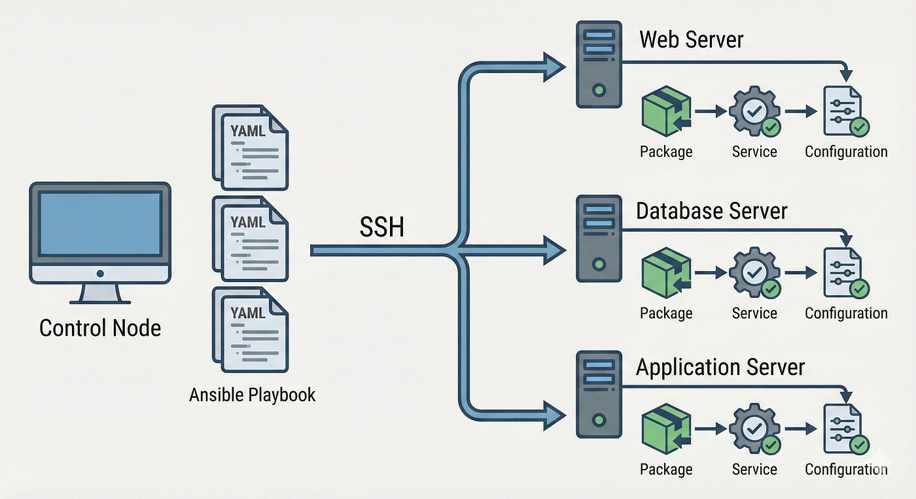
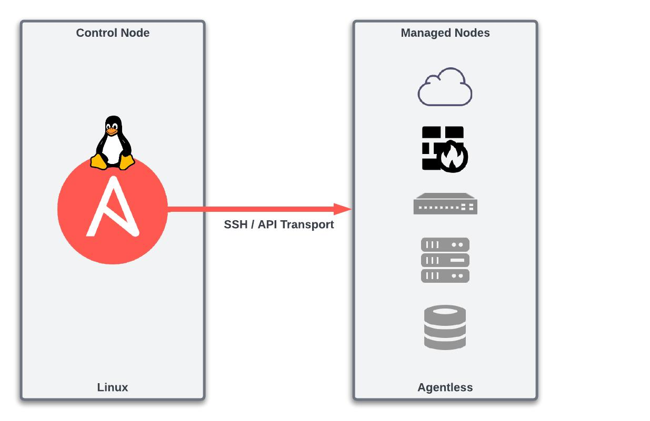
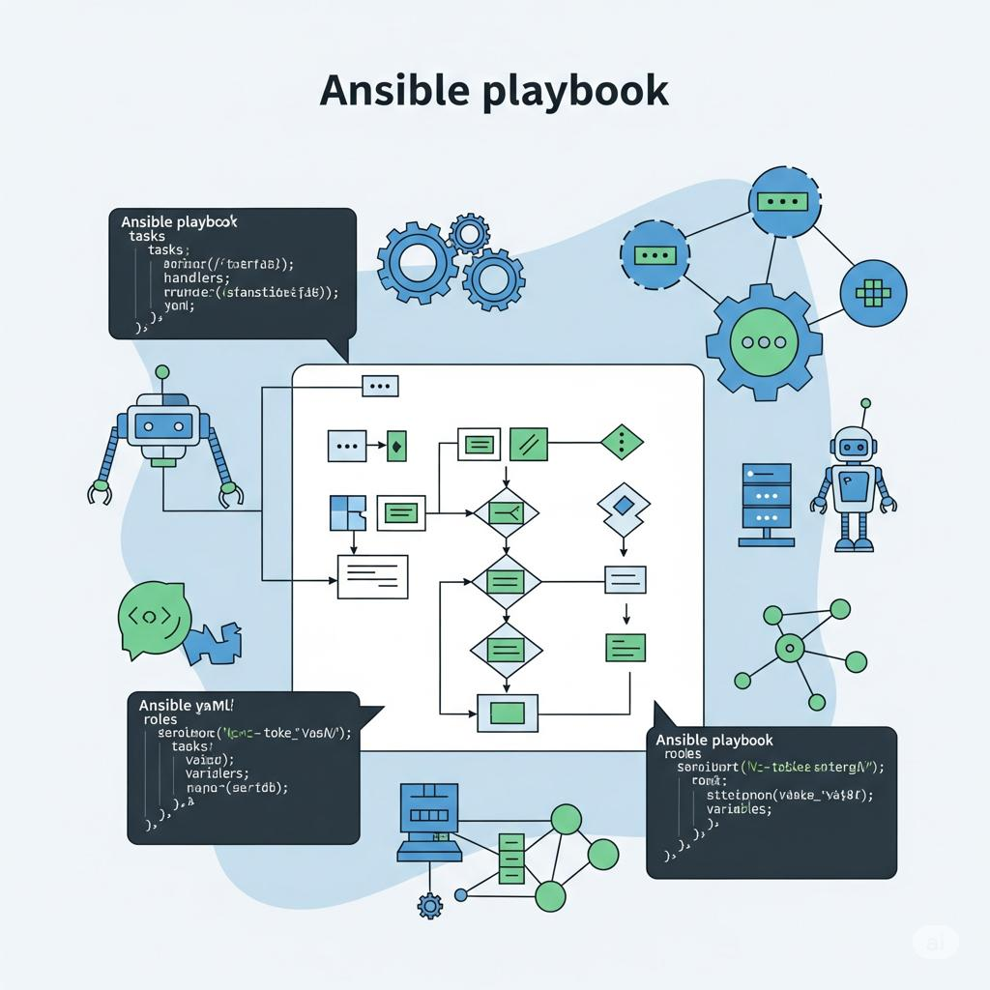
6
Ansible is one of the most popular configuration management and automation tools because it is simple, agentless, and easy to scale.
1. Agentless Architecture
- No software (agent) needs to be installed on managed servers.
- Uses SSH (Linux) or WinRM (Windows) to communicate.
- This reduces maintenance and improves security.
Benefit: Faster deployment and lower overhead.

2. Easy to Learn
- Uses YAML for playbooks.
- YAML is human-readable and easy to understand.
Example:
- name: Install Nginx
apt:
name: nginx
state: present
Benefit: Even beginners can write automation scripts.

3. Simple Installation
Install Ansible on only the Control Node.
sudo apt install ansible -y
No installation is required on target Linux servers.

4. Automates Repetitive Tasks
Instead of logging into each server individually, Ansible can perform tasks on many servers simultaneously.
Examples:
- Install software
- Create users
- Update packages
- Restart services
- Copy configuration files
Benefit: Saves time and reduces manual effort.

5. Manages Multiple Servers at Once
Control Node
|
---------------------
| | |
Server1 Server2 Server3
One command can configure hundreds of servers.

6. Idempotent
Ansible changes a system only when necessary.
Example:
- If Nginx is already installed, Ansible does not reinstall it.
Benefit:
- Prevents unnecessary changes.
- Ensures consistent system state.

7. Cross-Platform Support
Ansible can manage:
- Linux
- Windows
- AWS
- Azure
- Google Cloud
- VMware
- Kubernetes

8. Scalable
Ansible works well for:
- 10 servers
- 100 servers
- 1,000+ servers
It is suitable for both small and large organizations.

9. Improves Consistency
Every server receives the same configuration from the same playbook.
Benefit:
- Reduces configuration drift.
- Ensures all environments are configured consistently.

10. Easy Integration with DevOps Tools
Ansible integrates with tools such as:
- Git
- Jenkins
- Docker
- Kubernetes
- Terraform
- AWS
This makes it a key tool in DevOps pipelines.

Summary Table
Advantage | Description
Agentless | No agent required on managed servers
Easy to Learn | Uses simple YAML syntax
Simple Installation | Install only on the control node
Automation | Automates repetitive tasks
Multi-Server Management | Controls many servers simultaneously
Idempotent | Makes changes only when needed
Cross-Platform | Supports Linux, Windows, cloud platforms, and more
Scalable | Suitable for small and large infrastructures
Consistency | Ensures identical configurations across servers
DevOps Integration | Works well with CI/CD and cloud tools
Interview Answer (Short)
"Ansible is popular because it is agentless, easy to learn, uses YAML playbooks, automates repetitive tasks, manages multiple servers simultaneously, is idempotent, supports multiple platforms, scales easily, ensures consistent configurations, and integrates well with DevOps tools like Jenkins, Docker, Kubernetes, and Terraform."
What are Ansible Ad Hoc Commands?
An Ansible Ad Hoc Command is a one-line command used to perform a single task on one or more managed servers without creating a playbook.
Think of it as a quick command for immediate tasks.

Syntax
ansible <host-pattern> -m <module> -a "<arguments>"
Where:
- <host-pattern> → Target hosts (for example, all, webservers)
- -m → Module to execute
- -a → Arguments passed to the module

How Ad Hoc Commands Work
User
│
▼
Runs an Ad Hoc Command
│
▼
Control Node
(Ansible)
│
Reads Inventory
│
Connects via SSH
│
Executes Module
│
▼
Managed Nodes
│
▼
Returns Output

Common Examples
1. Check Connectivity (Ping)
ansible all -m ping
Output:
server1 | SUCCESS => {
"ping": "pong"
}

2. Check Disk Space
ansible all -m shell -a "df -h"

3. Check Memory Usage
ansible all -m shell -a "free -m"

4. Install Nginx (Ubuntu)
ansible webservers -m apt -a "name=nginx state=present" -b
- -b means become (use sudo privileges).

5. Start a Service
ansible webservers -m service -a "name=nginx state=started" -b

6. Copy a File
ansible all -m copy -a "src=test.txt dest=/tmp/test.txt"

7. Create a User
ansible all -m user -a "name=devops state=present" -b

8. Restart a Service
ansible all -m service -a "name=nginx state=restarted" -b

Commonly Used Modules in Ad Hoc Commands
Module | Purpose
ping | Check connectivity
shell | Run shell commands
command | Run commands (without shell features)
apt | Install/manage packages on Ubuntu/Debian
yum / dnf | Install/manage packages on RHEL/CentOS/Fedora
service | Start, stop, restart services
copy | Copy files
file | Manage files and directories
user | Create or manage users

Ad Hoc Commands vs Playbooks
Ad Hoc Commands | Playbooks
One-time tasks | Reusable automation
One-line commands | YAML files
Best for quick changes | Best for complex workflows
Not ideal for repeated tasks | Easy to version-control and reuse

When Should You Use Ad Hoc Commands?
Use them for:
- Checking server connectivity
- Installing a package quickly
- Restarting a service
- Copying a file
- Running a one-time command
- Checking disk or memory usage
Use playbooks when you need:
- Multiple tasks
- Repeatable automation
- Configuration management
- CI/CD workflows

Interview Definition
"Ansible Ad Hoc Commands are single-line commands used to execute one-time tasks on one or more managed hosts without creating a playbook. They use Ansible modules to perform operations such as checking connectivity, installing packages, managing services, copying files, and running shell commands."
What is an Ansible Playbook?

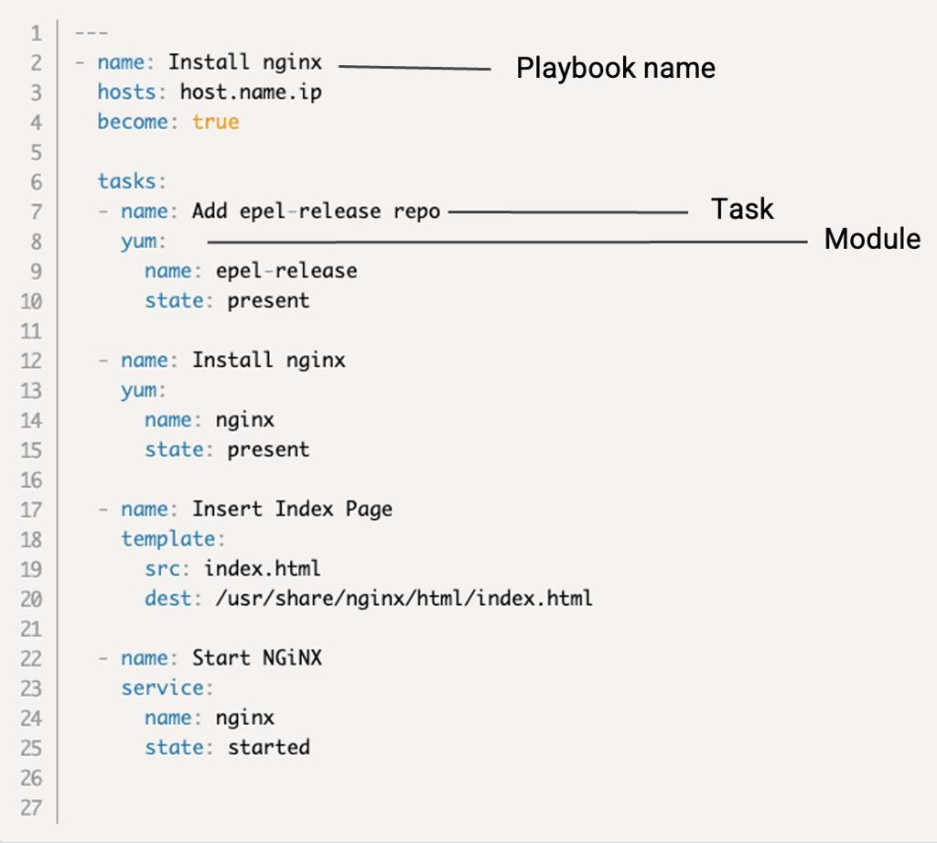
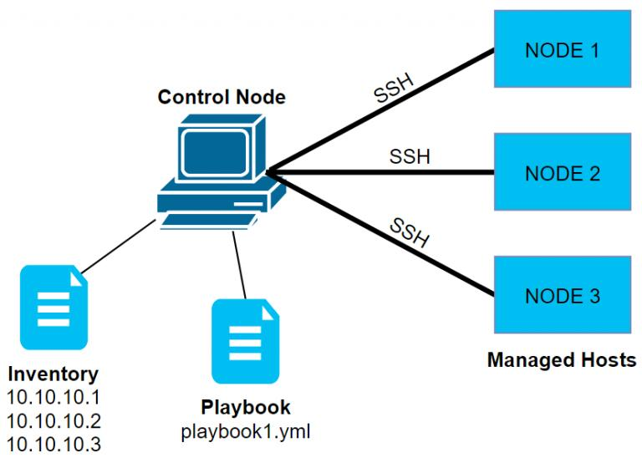
7
An Ansible Playbook is a YAML file (.yml or .yaml) that contains a series of tasks (called plays) to automate the configuration and management of one or more servers.
Think of a playbook as a recipe:
- Inventory = List of servers
- Playbook = Recipe (instructions)
- Tasks = Individual steps in the recipe
- Modules = Tools that perform the actual work

How an Ansible Playbook Works
User
│
▼
ansible-playbook site.yml
│
▼
Reads Inventory File
│
▼
Reads Playbook (YAML)
│
▼
Connects to Servers using SSH
│
▼
Executes Tasks One by One
│
▼
Returns Results (PLAY RECAP)

Basic Structure of a Playbook
---
- name: Install and Start Nginx
hosts: webservers
become: yes

tasks:
- name: Install Nginx
apt:
name: nginx
state: present

- name: Start Nginx
service:
name: nginx
state: started

Parts of a Playbook
Keyword | Purpose
--- | Start of the YAML document
name | Describes the play or task
hosts | Specifies which servers to target
become | Runs tasks with sudo privileges
tasks | List of actions to perform
apt / service | Ansible modules used to perform the task

Example: Install Nginx
Step 1: Inventory File
[webservers]
192.168.1.10
192.168.1.11
Step 2: Playbook (install_nginx.yml)
---
- name: Install Nginx on Web Servers
hosts: webservers
become: yes

tasks:
- name: Install Nginx
apt:
name: nginx
state: present

- name: Start Nginx Service
service:
name: nginx
state: started
Step 3: Run the Playbook
ansible-playbook -i inventory.ini install_nginx.yml

Execution Flow
Control Node
│
│ Reads inventory
▼
Inventory
│
▼
Playbook
│
▼
SSH Connection
│
┌────┴────┐
▼ ▼
Server1 Server2
│ │
Install Install
Nginx Nginx
│ │
└────┬─────┘
▼
PLAY RECAP

Sample Output
PLAY [Install Nginx on Web Servers]

TASK [Install Nginx]
changed: [192.168.1.10]
changed: [192.168.1.11]

TASK [Start Nginx Service]
ok: [192.168.1.10]
ok: [192.168.1.11]

PLAY RECAP
192.168.1.10 : ok=2 changed=1 failed=0
192.168.1.11 : ok=2 changed=1 failed=0

Advantages of Playbooks
- Easy to read because they use YAML.
- Reusable for repeated deployments.
- Automates multiple tasks in sequence.
- Supports idempotency (doesn't repeat unnecessary changes).
- Easy to store in Git and version-control.
- Can manage hundreds or thousands of servers.

Playbook vs Ad Hoc Commands
Ansible Playbook | Ad Hoc Command
YAML file | One-line command
Multiple tasks | Single task
Reusable | Mainly for one-time use
Best for automation | Best for quick operations
Easy to version-control | Not typically version-controlled

Real-World Example
Suppose your company launches 20 new web servers. Instead of logging into each server manually, you can create a playbook that:
- Installs Nginx.
- Starts the Nginx service.
- Copies the website files.
- Enables the service to start on boot.
Run a single command:
ansible-playbook deploy_webserver.yml
Ansible performs all these tasks on every target server automatically.

Interview Definition
"An Ansible Playbook is a YAML file that defines one or more plays, each containing tasks to automate configuration, deployment, and management of servers. When executed, Ansible reads the inventory, connects to the target hosts over SSH, runs the tasks in order, and reports the results."
What is Ansible Galaxy?
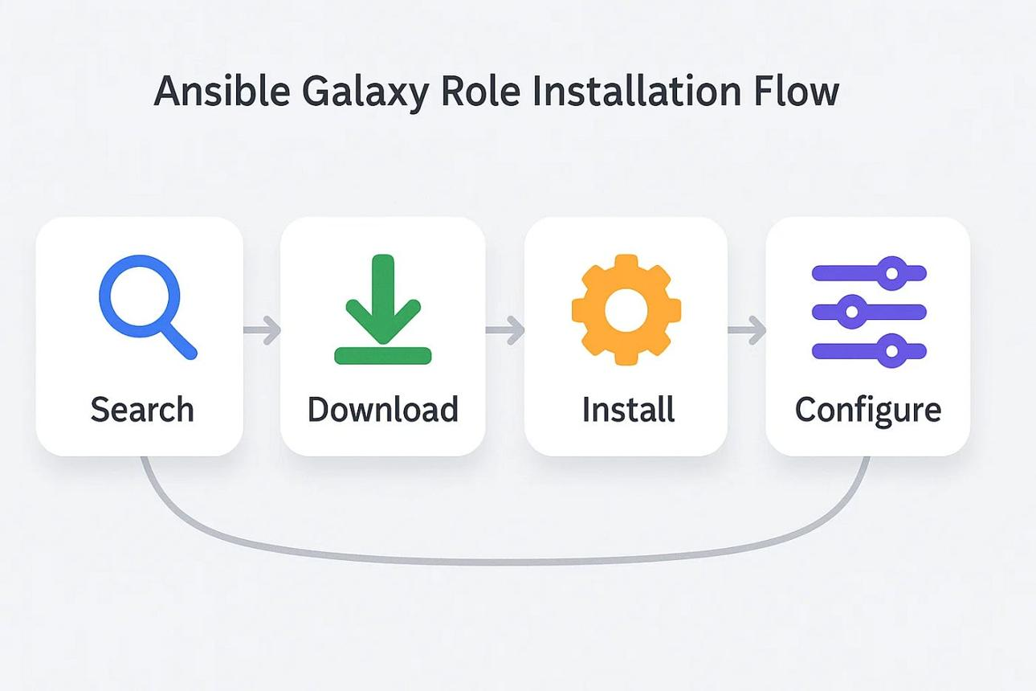
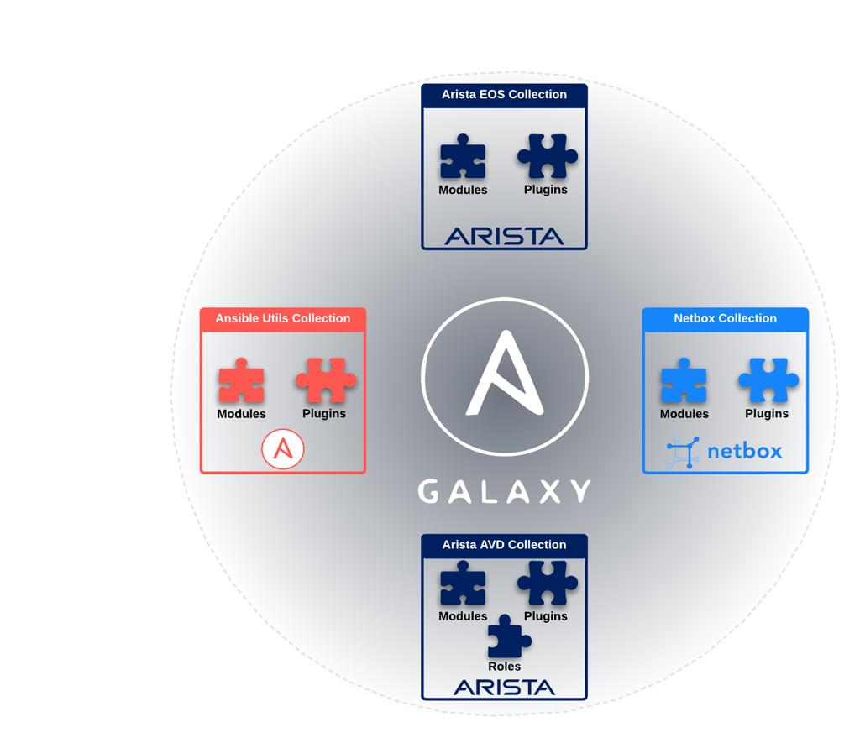
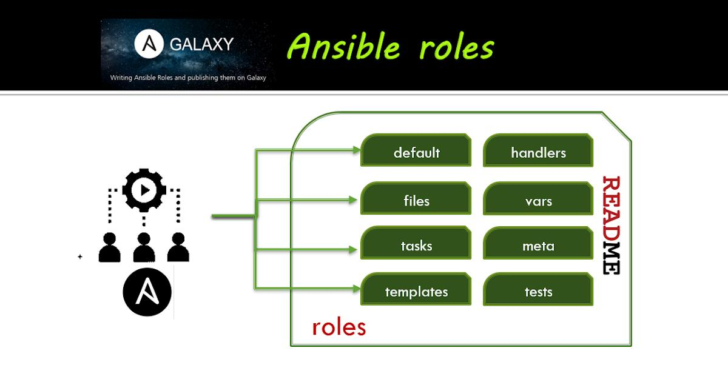
5
Ansible Galaxy is the official community repository for sharing and downloading reusable Ansible Roles and Collections.
Instead of writing everything from scratch, you can download pre-built automation created by the Ansible community or vendors.
Think of it like:
- GitHub → Stores source code
- Docker Hub → Stores Docker images
- Ansible Galaxy → Stores Ansible roles and collections

How Ansible Galaxy Works
User
│
▼
ansible-galaxy install
│
▼
Ansible Galaxy
(Roles & Collections)
│
▼
Downloads to Control Node
│
▼
Used in Playbooks
│
▼
Configures Servers

What is a Role?
A Role is a reusable package of Ansible automation.
For example, instead of writing tasks to install Nginx every time, you can use an existing Nginx role from Ansible Galaxy.
A role typically contains:
nginx-role/
├── tasks/
├── handlers/
├── templates/
├── files/
├── vars/
├── defaults/
├── meta/
└── README.md

Installing a Role
Example:
ansible-galaxy role install geerlingguy.nginx
This downloads the Nginx role to your system.

Using the Role in a Playbook
---
- hosts: webservers
become: yes

roles:
- geerlingguy.nginx
Run it:
ansible-playbook nginx.yml
Ansible uses the downloaded role to install and configure Nginx.

Installing a Collection
A Collection is a bundle of:
- Roles
- Modules
- Plugins
- Documentation
Example:
ansible-galaxy collection install amazon.aws
This installs the AWS collection, which includes modules for managing AWS resources such as EC2, S3, IAM, and VPC.

Common Commands
Search for a Role
ansible-galaxy search nginx
Install a Role
ansible-galaxy role install geerlingguy.nginx
List Installed Roles
ansible-galaxy role list
Remove a Role
ansible-galaxy role remove geerlingguy.nginx
Install a Collection
ansible-galaxy collection install amazon.aws
List Installed Collections
ansible-galaxy collection list

Advantages of Ansible Galaxy
- Saves time by reusing existing automation.
- Provides community-tested roles and collections.
- Encourages standardization across projects.
- Makes playbooks smaller and easier to maintain.
- Simplifies managing complex software like Nginx, MySQL, Kubernetes, and cloud services.

Real-World Example
Suppose your company needs to install Nginx on 100 servers.
Without Ansible Galaxy
- Write all installation and configuration tasks yourself.
With Ansible Galaxy
- Install a trusted Nginx role:
ansible-galaxy role install geerlingguy.nginx
- Reference the role in your playbook.
- Run the playbook on all 100 servers.
This reduces development time and uses automation that has already been tested.

Ansible Galaxy vs Roles
Ansible Galaxy | Role
Repository for sharing automation | Reusable unit of automation
Stores roles and collections | Contains tasks, handlers, variables, templates, etc.
Used to download automation | Used inside playbooks

Interview Definition
"Ansible Galaxy is the official repository for Ansible roles and collections. It allows users to search, download, share, and reuse pre-built automation, reducing development time and promoting standardized, reusable infrastructure automation."
What are Ansible Modules?
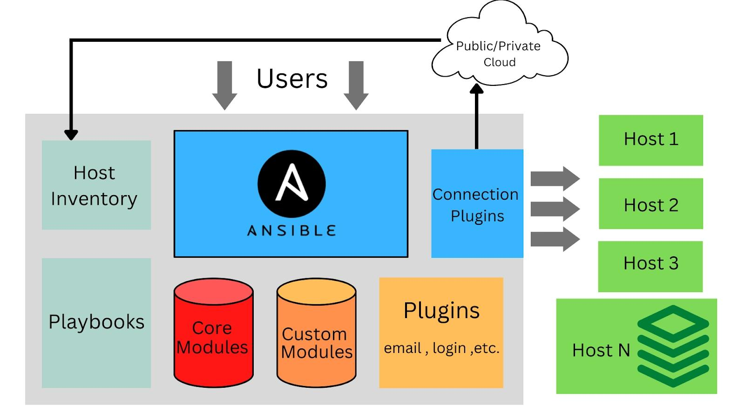
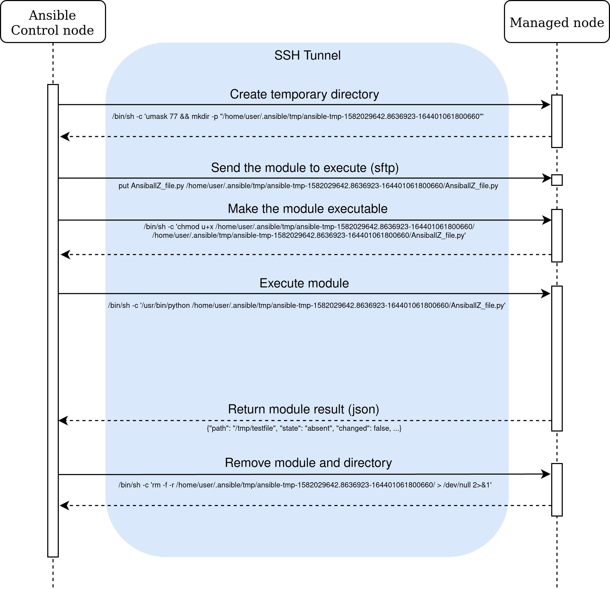
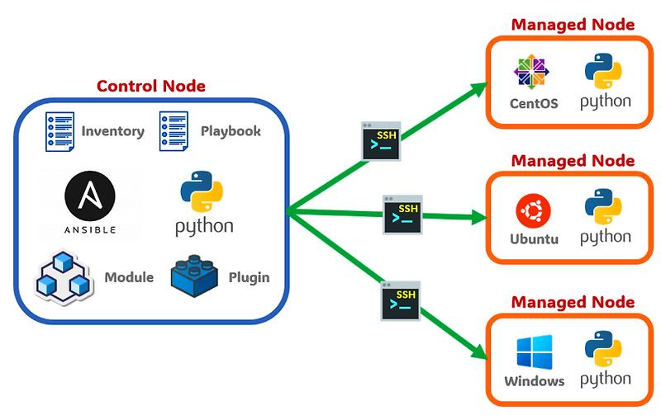
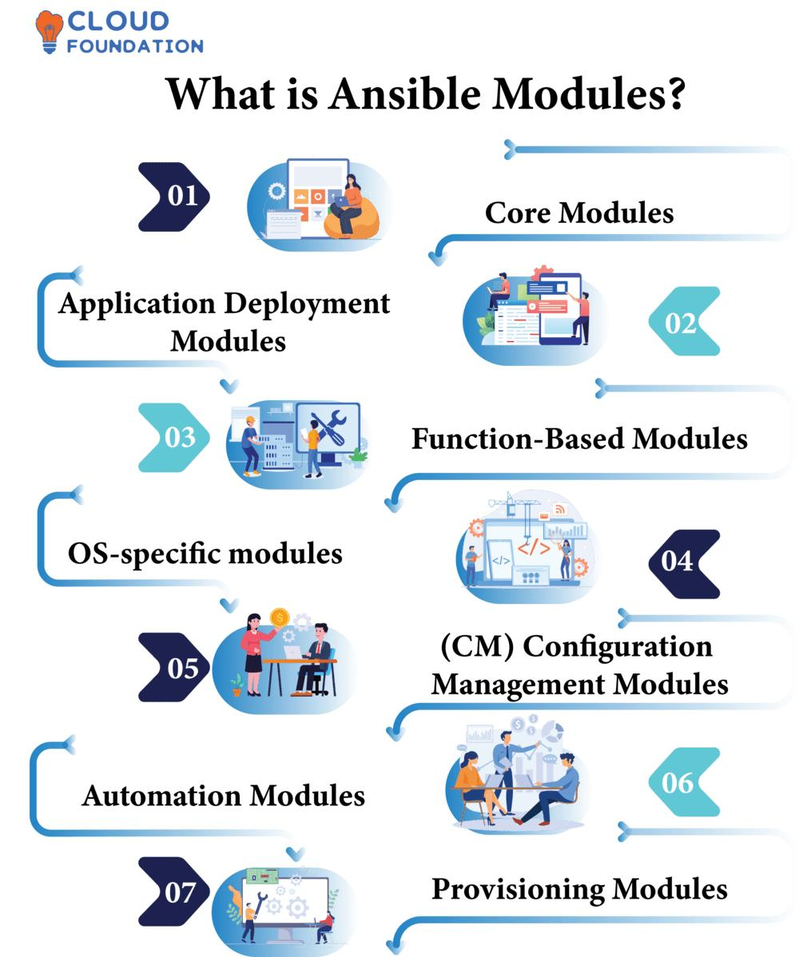
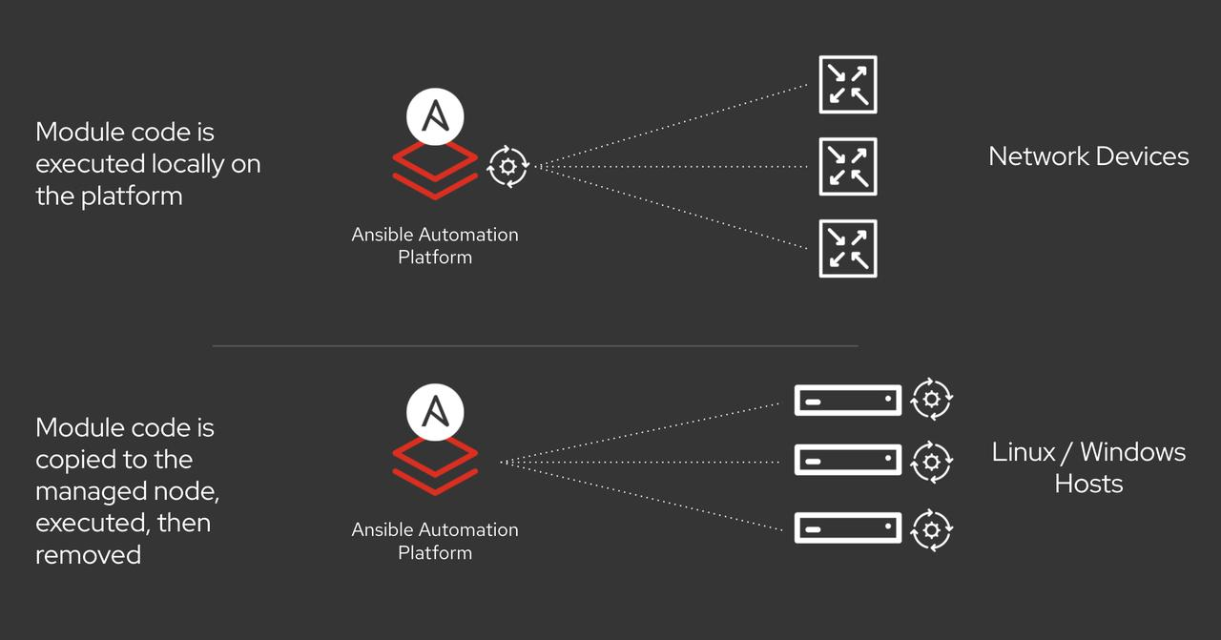
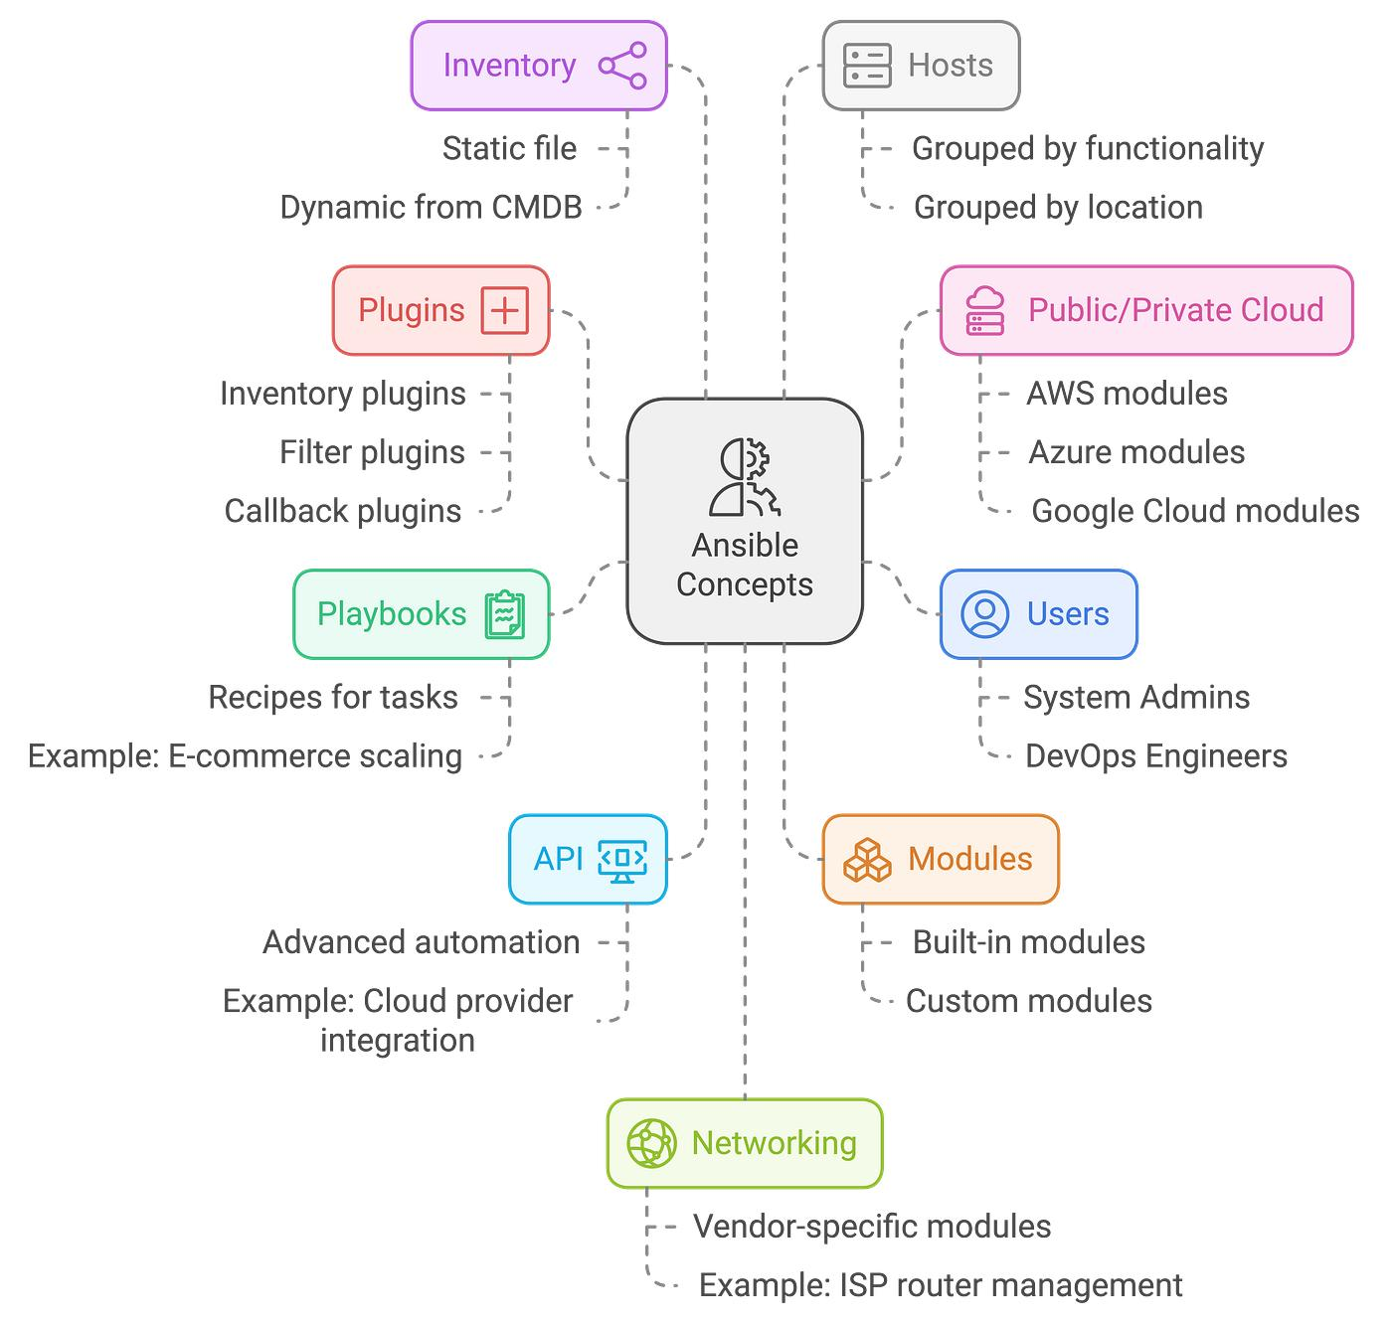
An Ansible Module is a small program or unit of work that performs a specific task on a managed node.
When you run an Ansible command or playbook, Ansible calls a module to perform the actual operation.
Think of it this way:
- Playbook → The plan (recipe)
- Task → One step in the plan
- Module → The tool that performs the step

How Ansible Modules Work
User
│
▼
Run Playbook/Ad Hoc
│
▼
Ansible Control Node
│
Selects the Module
│
Connects via SSH
│
▼
Managed Node
│
Executes the Module
│
▼
Returns the Result

Example
Playbook:
---
- hosts: webservers
become: yes

tasks:
- name: Install Nginx
apt:
name: nginx
state: present
In this example:
- Task: Install Nginx
- Module: apt
The apt module installs the package on Ubuntu/Debian systems.

Commonly Used Ansible Modules
Module | Purpose | Example
ping | Check connectivity | ansible all -m ping
apt | Install/manage packages on Ubuntu/Debian | Install Nginx
yum | Install/manage packages on RHEL/CentOS | Install Apache
dnf | Package management on Fedora/RHEL 8+ | Install packages
service | Start, stop, restart services | Start Nginx
copy | Copy files | Copy config files
file | Create/delete files and directories | Create a directory
user | Create or manage users | Add a user
group | Create or manage groups | Add a group
command | Run a command (without shell features) | uptime
shell | Run shell commands | df -h && free -m
git | Clone or update Git repositories | Clone a repo
cron | Manage cron jobs | Schedule a script

Examples of Modules
1. Ping Module
ansible all -m ping
Output:
server1 | SUCCESS => {
"ping": "pong"
}

2. Install Nginx
ansible webservers -m apt -a "name=nginx state=present" -b

3. Start a Service
ansible webservers -m service -a "name=nginx state=started" -b

4. Copy a File
ansible all -m copy -a "src=index.html dest=/var/www/html/index.html"

5. Create a User
ansible all -m user -a "name=devops state=present" -b

6. Create a Directory
ansible all -m file -a "path=/opt/app state=directory"

Types of Ansible Modules
Type | Description
System Modules | Manage users, files, packages, services
Command Modules | Run Linux commands (command, shell)
Cloud Modules | Manage AWS, Azure, Google Cloud resources
Network Modules | Configure routers, switches, firewalls
Database Modules | Manage MySQL, PostgreSQL, MongoDB
Storage Modules | Manage disks, volumes, file systems

Module Execution Flow
Playbook
│
▼
Task
│
▼
Module
│
▼
SSH Connection
│
▼
Managed Server
│
▼
Task Executed
│
▼
Result Returned

Advantages of Ansible Modules
- Reusable – Use the same module across many playbooks.
- Simple – Perform common tasks with minimal syntax.
- Idempotent – Most modules make changes only when needed.
- Cross-platform – Many modules work across Linux, Windows, cloud platforms, and network devices.
- Extensive library – Thousands of built-in and community modules are available.

Interview Definition
"Ansible Modules are reusable units of work that perform specific tasks on managed nodes, such as installing packages, managing users, copying files, or controlling services. They are the building blocks of Ansible playbooks and ad hoc commands."
Basic Ansible Interview Questions
1. What is Ansible?
Answer:
Ansible is an open-source IT automation and configuration management tool used to automate software installation, server configuration, application deployment, and orchestration. It is agentless and uses SSH to communicate with managed nodes.

2. Who created Ansible?
Answer:
Ansible was created by Michael DeHaan in 2012 and was later acquired by Red Hat in 2015.

3. Why is Ansible mostly used?
Answer:
- Configuration Management
- Application Deployment
- Server Provisioning
- Automation
- Orchestration

4. What is Configuration Management?
Answer:
Configuration Management is the process of maintaining servers in a consistent and desired state by automating software installation, configuration, updates, and system settings.

5. Why is Ansible called an Agentless tool?
Answer:
Because no software (agent) needs to be installed on managed nodes. It uses SSH (Linux) or WinRM (Windows).

6. What are the main components of Ansible?
Answer:
- Control Node
- Managed Nodes
- Inventory
- Modules
- Playbooks
- Roles
- Collections

7. What is an Inventory?
Answer:
An inventory is a file that contains the list of hosts or servers Ansible manages.
Example:
[webservers]
192.168.1.10
192.168.1.11

8. What is Static Inventory?
Answer:
A manually maintained inventory file.

9. What is Dynamic Inventory?
Answer:
An inventory that automatically discovers servers from cloud providers like AWS, Azure, or GCP.

10. What is a Playbook?
Answer:
A Playbook is a YAML file that contains automation tasks to configure and manage servers.

11. Why are Playbooks written in YAML?
Answer:
Because YAML is:
- Human-readable
- Easy to write
- Easy to maintain

12. What are Ansible Modules?
Answer:
Modules are reusable programs that perform specific tasks such as installing packages, creating users, copying files, or starting services.

13. Give some commonly used modules.
Answer:
- ping
- apt
- yum
- dnf
- service
- copy
- file
- user
- shell
- command
- git
- cron

14. What are Ad Hoc Commands?
Answer:
Single-line commands used to perform one-time tasks without creating a playbook.
Example:
ansible all -m ping

15. Difference between Ad Hoc Commands and Playbooks?
Ad Hoc | Playbook
One-time task | Multiple tasks
One-line command | YAML file
Not reusable | Reusable

16. What is YAML?
Answer:
YAML stands for YAML Ain't Markup Language. It is a human-readable data serialization language used to write Ansible playbooks.

17. What is Idempotency in Ansible?
Answer:
Idempotency means running the same playbook multiple times produces the same result without making unnecessary changes.
Example:
- If Nginx is already installed, Ansible won't reinstall it.

18. What is a Role?
Answer:
A Role is a reusable directory structure that organizes tasks, variables, handlers, templates, and files.

19. What is Ansible Galaxy?
Answer:
Ansible Galaxy is the official repository for downloading and sharing reusable roles and collections.

20. What is a Collection?
Answer:
A Collection is a package containing modules, roles, plugins, and documentation.

21. Difference between Role and Collection?
Role | Collection
Contains automation for one purpose | Can contain multiple roles, modules, and plugins
Used in playbooks | Distributed as a package

22. What is the Inventory File Location?
Default location:
/etc/ansible/hosts

23. Which protocol does Ansible use?
Answer:
- SSH (Linux)
- WinRM (Windows)

24. What is become: yes?
Answer:
It runs tasks with elevated (sudo) privileges.
Example:
become: yes

25. Difference between command and shell modules?
command | shell
Doesn't use the shell | Uses the shell
More secure | Supports pipes, redirection, variables
Can't use ` | or>`
Example:
ansible all -m command -a "uptime"
ansible all -m shell -a "df -h && free -m"

26. What is the difference between copy and template?
copy | template
Copies a file as-is | Processes Jinja2 variables before copying
Static content | Dynamic content

27. What is a Handler?
Answer:
A handler is a special task that runs only when notified, usually after a change.
Example:
- Restart Nginx only if its configuration file changes.

28. How do you check Ansible connectivity?
ansible all -m ping

29. How do you execute a Playbook?
ansible-playbook playbook.yml

30. What are the advantages of Ansible?
Answer:
- Agentless
- Easy to learn
- Uses YAML
- Idempotent
- Supports multiple platforms
- Automates repetitive tasks
- Scalable
- Integrates with DevOps tools

Scenario-Based Interview Questions
Q1: You have 100 servers. How would you install Nginx on all of them?
Answer:
Create an inventory, write a playbook using the apt (or yum) module, and run it with:
ansible-playbook install_nginx.yml

Q2: A new AWS EC2 instance is launched. How will Ansible detect it automatically?
Answer:
By using a dynamic inventory (for example, the AWS EC2 inventory plugin), which queries AWS for the current list of instances.

Q3: How do you restart a service only if its configuration changes?
Answer:
Use a handler that is notified by the task updating the configuration.

Q4: Which module would you use to create a user?
Answer:
The user module.

Q5: Which module would you use to install packages?
Answer:
- apt for Ubuntu/Debian
- yum or dnf for RHEL-based systems

Frequently Asked Commands
ansible --version
ansible all -m ping
ansible-playbook playbook.yml
ansible-inventory --list
ansible-galaxy role install geerlingguy.nginx
ansible-galaxy collection list
ansible all -m shell -a "df -h"
ansible all -m copy -a "src=file.txt dest=/tmp/file.txt"
Tip for Freshers
Since you've been studying Git, Linux, AWS, and Ansible, many interviewers will ask you to explain a simple end-to-end automation. For example:
"I launch an EC2 instance on AWS, add it to the Ansible inventory (or use dynamic inventory), run an Ansible playbook to install and start Nginx, and verify the website is accessible. The playbook uses modules such as apt and service, and because Ansible is idempotent, running it again won't make unnecessary changes."
Being able to explain this workflow clearly often leaves a stronger impression than memorizing many definitions.
Variables and Facts in Ansible
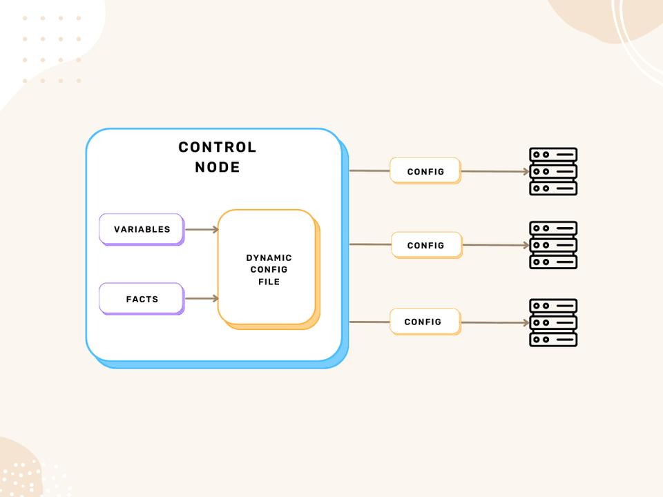
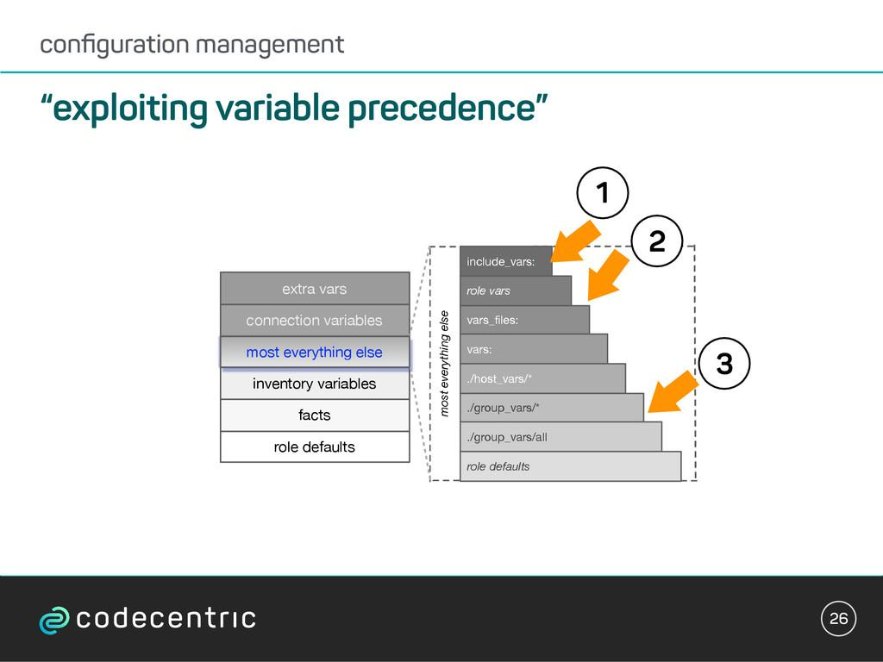
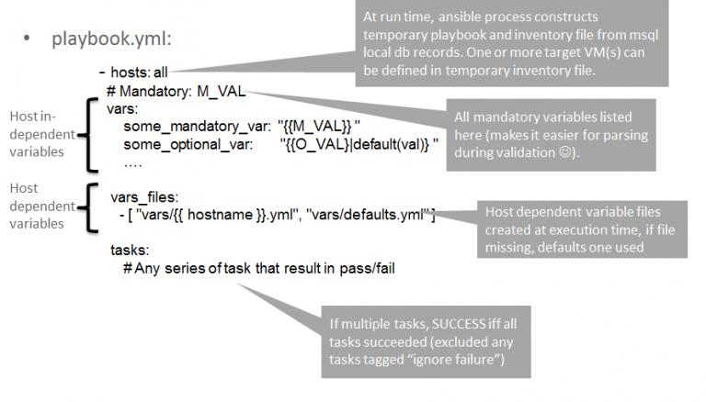
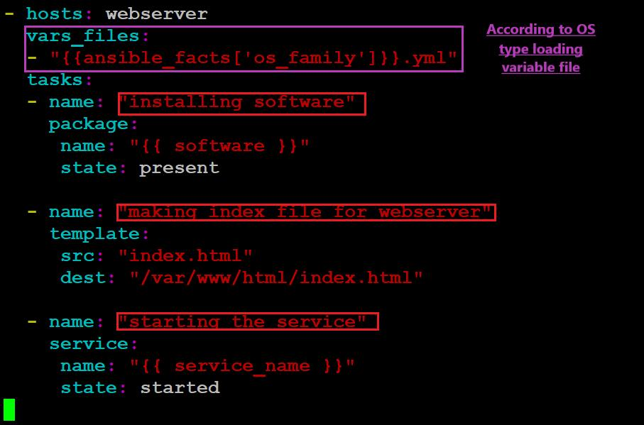
Variables and facts are used to make Ansible playbooks dynamic and reusable.
- Variables are values defined by the user.
- Facts are information automatically collected by Ansible from the managed host.

What are Variables?
A variable is a user-defined value that can be reused throughout a playbook.
Instead of hardcoding values, you store them in variables.
Example
---
- hosts: webservers

vars:
package_name: nginx

tasks:
- name: Install package
apt:
name: "{{ package_name }}"
state: present
Here:
- package_name is a variable.
- {{ package_name }} is Jinja2 syntax used to reference the variable.

Why Use Variables?
- Avoid repeating values.
- Make playbooks reusable.
- Easy to update configurations.
- Improve readability.
Example:
Instead of:
name: nginx
Use:
name: "{{ package_name }}"
If you later want to install Apache, change only the variable:
package_name: apache2

Ways to Define Variables
1. Inside the Playbook
vars:
package_name: nginx

2. Inventory Variables
[webservers]
server1 ansible_host=192.168.1.10 http_port=80

3. External Variable File
vars.yml
package_name: nginx
service_name: nginx
Playbook:
vars_files:
- vars.yml

4. Command Line Variables
ansible-playbook site.yml -e "package_name=nginx"

What are Facts?
Facts are details about a managed node that Ansible gathers automatically before running tasks.
Examples of facts:
- Hostname
- Operating System
- IP Address
- Memory
- CPU
- Architecture
- Disk Information
- Kernel Version

How Facts Work
Playbook
│
▼
Gather Facts
│
▼
Managed Server Information
│
┌────────────┼────────────┐
▼ ▼ ▼
Hostname IP OS Version
│
▼
Used in Playbook

Gathering Facts
By default:
gather_facts: yes
Ansible automatically collects system information.
To disable:
gather_facts: no

Viewing Facts
Run:
ansible all -m setup
This displays all collected facts.
Example output:
ansible_hostname: webserver01
ansible_distribution: Ubuntu
ansible_distribution_version: "22.04"
ansible_processor_vcpus: 2
ansible_memtotal_mb: 3945
ansible_default_ipv4:
address: 192.168.1.10

Using Facts in a Playbook
---
- hosts: all

tasks:
- name: Display hostname
debug:
msg: "{{ ansible_hostname }}"
Output:
webserver01

Common Facts
Fact | Description
ansible_hostname | Hostname
ansible_distribution | Operating system
ansible_distribution_version | OS version
ansible_architecture | CPU architecture
ansible_processor_vcpus | Number of CPUs
ansible_memtotal_mb | Total RAM
ansible_kernel | Kernel version
ansible_default_ipv4.address | Primary IP address

Variables vs Facts
Variables | Facts
Defined by the user | Collected automatically by Ansible
Can be changed anytime | Reflect the current system state
Used to customize playbooks | Used to make decisions based on the target host
Example: package_name: nginx | Example: ansible_hostname

Real-World Example
Suppose you want to display the hostname and install a package whose name is stored in a variable.
---
- hosts: all
become: yes

vars:
package_name: nginx

tasks:
- name: Display hostname
debug:
msg: "Hostname is {{ ansible_hostname }}"

- name: Install package
apt:
name: "{{ package_name }}"
state: present
Here:
- Variable: package_name
- Fact: ansible_hostname

Interview Questions
1. What is a variable in Ansible?
Answer: A variable is a user-defined value used to make playbooks flexible and reusable.

2. What are Ansible facts?
Answer: Facts are system information automatically gathered from managed hosts, such as hostname, IP address, OS, memory, and CPU details.

3. Which module gathers facts?
Answer: The setup module gathers facts.
Example:
ansible all -m setup

4. What is the difference between variables and facts?
Answer:
- Variables are defined by the user.
- Facts are automatically collected by Ansible from the managed hosts.

Interview Definition
Variables are user-defined values that make Ansible playbooks reusable and configurable, while facts are automatically collected system details about managed hosts, such as hostname, operating system, IP address, CPU, and memory, which can be used to make playbooks adapt to different environments.
MobaXterm is only an SSH client/terminal emulator. You do not install Ansible on MobaXterm itself. Instead, you install Ansible on the Ubuntu Linux server that you connect to using MobaXterm.
Since you've been using an AWS Ubuntu EC2 instance in your DevOps course, install Ansible on that EC2 instance.

Step 1: Connect to Your Ubuntu Server
Open MobaXterm and connect to your EC2 instance using SSH.
Example:
ssh -i "C:\Users\ASUS\Desktop\aws keys\my_server-1-key.pem" ubuntu@<your-public-ip>

Step 2: Update the Package List
sudo apt update

Step 3: Install Ansible
sudo apt install ansible -y

Step 4: Verify the Installation
ansible --version
Example output:
ansible [core 2.16.x]
python version = 3.x.x

Step 5: Check the Inventory File
cat /etc/ansible/hosts
If the file doesn't exist, don't worry—you can create your own inventory later.

Step 6: Test Ansible
Check the version:
ansible --version
Check available modules:
ansible-doc -l

Complete Installation Commands
sudo apt update
sudo apt install ansible -y
ansible --version

Architecture
Windows Laptop
+--------------------+
| MobaXterm |
+--------------------+
│
SSH Connection
│
▼
+--------------------+
| Ubuntu EC2 Server |
| Ansible Installed |
+--------------------+
│
▼
Managed Servers

Common Mistake
❌ Installing Ansible on Windows inside MobaXterm
✔ Correct: Install Ansible on the Ubuntu server that you access through MobaXterm.

Since you're learning DevOps
I remember you're using an Ubuntu EC2 instance on AWS.
Can you run these commands and share the output?
lsb_release -a
and
ansible --version
If Ansible is not installed yet, I'll guide you through the installation step by step.

